**TOPIC: DEXTER**

**NAME: - DARSHAN GAVKAR**

TABLE OF CONTENTS

1. ABSTRACT

2. CHAPTER 1-INTRODUCTION

1.1 BACKGROUND

1.2 OBJECTIVES

1.3 PURPOSE

1.4 SCOPE

1.5 APPLICABILITY

1.6 ACHIEVEMENTS

3.CHAPTER 2-SURVEY OF TECHNOLOGIES

4. CHAPTER 3-REQUIREMENTS AND ANALYSIS

3.1 PROBLEM DEFINITION

3.2 REQUIREMENTS SPECIFICATION

3.3 PLANNING AND SCHEDULING

3.4 SOFTWARE AND HARDWARE REQUIREMENTS

3.5 PRELIMINARY PRODUCT DESCRIPTION

5. CHAPTER 4-SYSTEM DESIGN

4.1 BASIC MODULES

4.2 DATA DESIGN

4.3 SCHEMA DESIGN

4.4 DATA INTEGRITY AND CONSTRAINTS

4.5 PROCEDURAL DESIGN

4.6 LOGIC DIAGRAM

4.7 DATA STRUCTURE

4.8 ALGORITHM DESIGN

4.9 USER INTERFACE DESIGN

4.10 SECURITY ISSUES

4.11 TEST CASE DESIGN

4.12 ARDUINO CODE

4.13 DATABASE CODE

6. CHAPTER 5-RESULTS AND DISCUSSION

5.1 TEST REPORTS

7.CHAPTER 6-CONCLUSION

6.1 CONCLUSION

6.2 LIMITATION OF THE SYSTEM

6.3 FUTURE SCOPE

8.GLOSSARY

ABSTRACT

Due to the rise of temperature and various harmful substances into the environment there is a need to reduce it and to look and help to healthy and bright future which could help overcome various health and other issues related to it and minimalize the expenditure and help uprising of the natural things which are about to get extent and even makes things less vulnerable and easy to sustain things for the benefits of mankind.

INTRODUCTION

* 1. BACKGROUND:
* This sensor has a history behind it which made it a top product for the usage.
* It also gave a peak to its usage and consumption.
* It is a multiple purpose sensor which can be used to measure pressure,humidity,pressure and gas.
* We can use this device in GPS,IOT devices and other devices where you can Implement this.
  1. OBJECTIVES:
* The need of this was felt to develop as there were no such materials who could give the visual view about a specific thing and helping in unconditional environment.
* The could help for being specific in measures based on the calamities.
* The main purpose urged is due to the unconditional environmental changes.
* Which causes the loss of many things which are being used by the numerous people around us.
* So to decline it from getting worse the need for thing came into existence.

1.3PURPOSE, SCOPE, APPLICABILITY

1.3.1 PURPOSE:

* As in today’s world people want many things to happen once without using most of time and money .
* It can help to improve the calamity things if we look into it and help the environment.
* The main purpose is to protect the environment from getting worst and help it get well being for the next generation
* So they could not face the problems as we are facing it could for the well being of world if individual efforts into it.

1.3.2 SCOPE:

* The sensors can be used for weather forecasting, pollution detection.
* It could minimalize human adverse effects for us and the growing generation.
* The best part we would get vegetables and fruits without any damage and could reduce the cost.
* Could also save a farmers life if he manages to follow all the requirements.\

1.3.3 APPLICABILITY:

* This could be applicable anywhere were we want to stop some severe things from happening.
* This could let us know the weather and the disasterous substances around us.
* This also make the world global warming free.
* This could cause a major impact for human being which will also give them the information and importance of the environment.

1.4 ACHIEVEMENTS:

* This could make the environment good and pollution free with proper and daily use.
* This could cut off your spendings on day to day basis.
* Takes care of the problems and provides solution to it.
* Compact so no need for space allocation.
* Farmers could rely and grow their crops without any life threathening as it also gives solution for the things to perform to sustain that good.

SURVEY OF TECHNOLOGIES

* It actually means the preceding works and the outcomes from it.
* The survey is basically is a method of gathering information from a sample of people traditionally with the intention of generalizing.
* While surveys vary widely in how they are conducted and used, there are a number of components that are common across nearly a surveys.
* Millions of surveys are sent out each year and although some companies still send out paper surveys, there would be a lot wasted paper it most were not digital.
* There are four modes of survey data collection that are commonly used:-

1. Face-to-face surveys.
2. Telephone surveys.
3. Self-administered paper and pencil surveys.
4. Self-administered computer surveys(online).

* Face-to-face surveys:-
* In a face-to-face survey, is a telephone survey is a telephone survey without the telephone.
* The interviewer physically travels to the respondents location to conduct a personal interview.
* Compared with mail and telephone surveys, face-to-face offer significant advantages in terms of the amount and complexity of the data can be collected.
* Face-to-face surveys also offer advantages in terms of data quality.
* Telephone surveys:-
* Telephone surveys are relatively easy to conduct and analyze, due in part to computer-assisted telephone interviewing.
* Being able to talk to interviewees and enter data directly in to a computer in real time means researches can garner results immediately,
* Phone surveys, on the other hand, don’t require any of those things.
* People can easily dismiss a direct-mail flyer or email, but its harder to ignore a real person asking for help with something.
* Self-administered paper and pencil surveys: -
* Paper and pencil interviewing is the most frequently used method for data collecting.
* It presents a process of personal interviewing where the polister holds a printed-out questionnaire, reads the question to the respondent and fills, the answers into the questionnaire.
* It is a suitable method for asking closed, e.g. multiple-choice questions and for open ended questions as well.
* Personal contact with participants might elicit richer and more detailed responses.
* Self-administered computer survey: -
* It refers to a variety of surveys modes that were enabled by the introduction of computer technology.
* The first modes were interviewer-administered, while later on computerized self-administered questionnaire appeared.
* It reduces time and costs for data input
* Elimination of errors during data transcription
* Implementation of advanced features such as automatic skips and branching, randomization of questions and response option, control of answer validity and inclusion of multimedia elements.
* Higher data quality due to absence of interviewer related bias.

REQUIREMENTS AND ANALYSIS

3.1 PROBLEM DEFINITION :

* The main cause of the project was the increasing pollutions.
* This leads to give rise to a global warming and affect the environment.
* This degraded the environment and get it to worsen itself.
* The people around weren’t aware about the climatical things and how to deal with this stuffs.
* So this caused them the failure to look into the conditions and carry with it.

3.2 REQUIREMENTS SPECIFICATIONS:

* The requires an application will can be downloaded via the internet platform which is free to download and use.
* It has a Bluetooth connectivity which helps it to connect with your mobile devices around to an extend of 400m and get notified about the happening which usually occurs.
* This things are handy and could cost around 5k Indian rupees.
* This project is portable as well and it interact with the user via a database which gets to know the problems and gives a specific solution to it.
* This project is only applicable for smart phones and not for basic phones.
* This would help people to minimalize the toxic effects of the environment which are happening due to such unexpected conditions.

3.3 PLANNING AND SCHEDULING:

* As of now there weren’t any stuffs which could look into the environment and give you the affects it can cause and how to improve it.
* Even for farmers its like they weren’t knowing what to do if they don’t have resources to use and what further steps should be taken care of by them.
* So implementing this could help them sustain their goods and reduce the lose to them which could actually cut off the expenditure of common people spendings on such goods they buy.
* It is a compact tool around a 30cm which can be kept anywhere but out of water conditions.
* They have a specific baseline for each of the things they do rely on accordingly the alerts will get provided to them and following things should be done accordingly which could help them to lose something.
* This could be a boon if associated with it with farmers and could easily give them the hope to produce their stuffs instead of doing something wrong and getting wrecked.

3.4 SOFTWARE AND HARDWARE REQUIREMENTS:

HARDWARE REQUIRED:

1. ARDUINO (OPTIONAL)

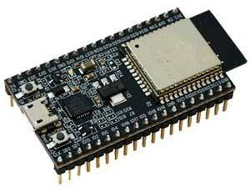

1. SEEEDUINO

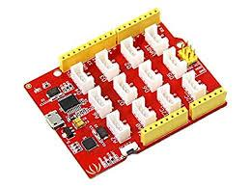

1. BASE SHIELD

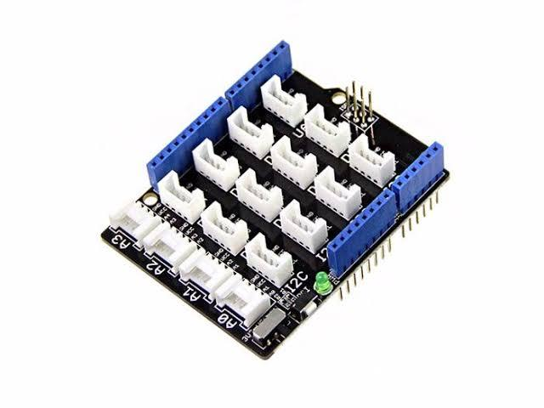

1. BREADBOARD

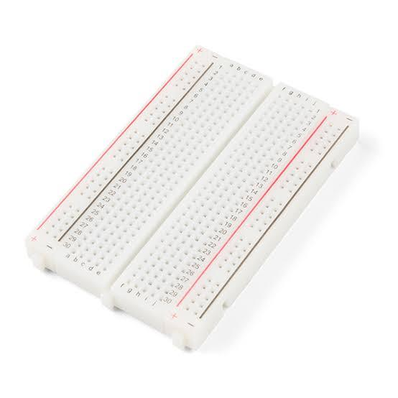

1. JUMPER WIRES

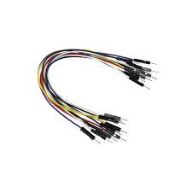

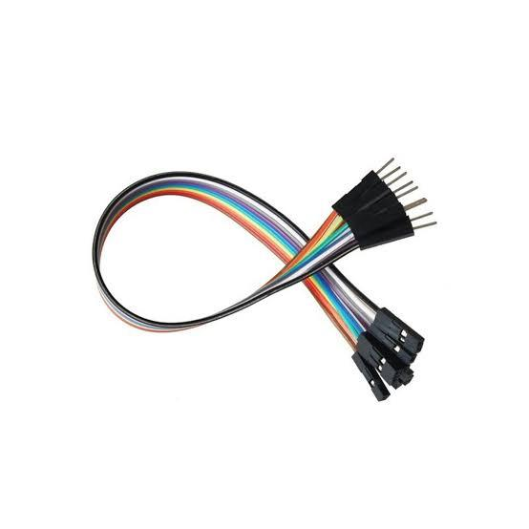

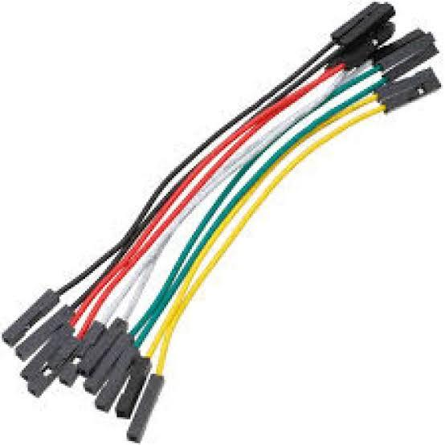

1. DHT11

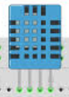

1. SOIL SENSOR

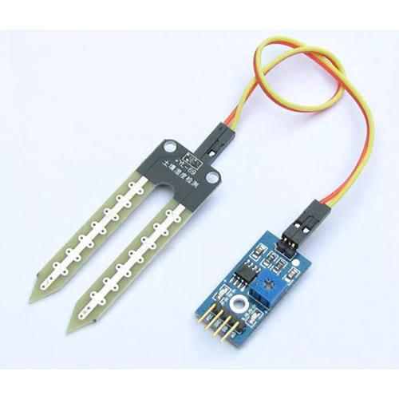

1. LCD DISPLAY

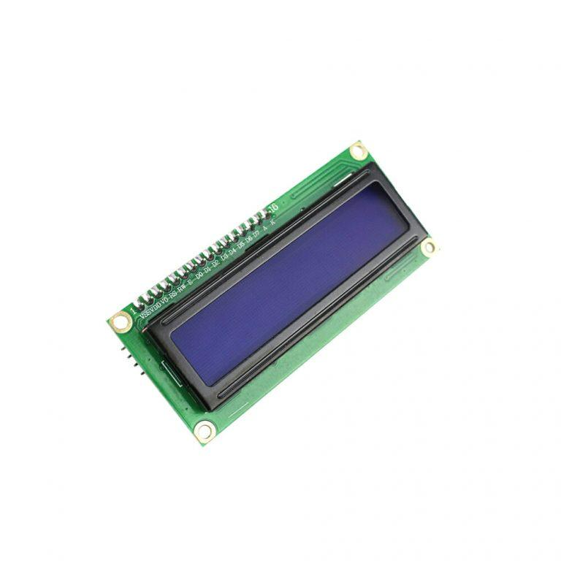

1. RASPBERRY PI (OPTIONAL)

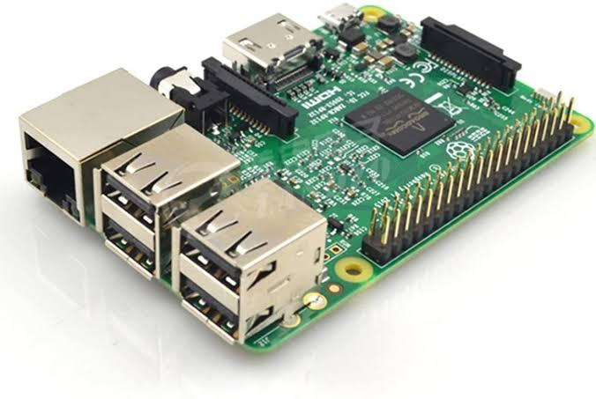

1. POTENTIOMETER

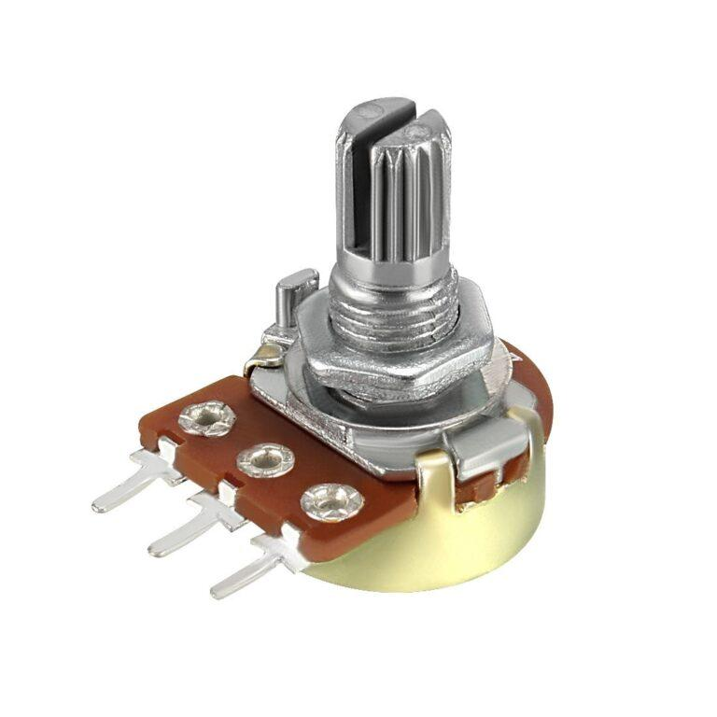

SOFTWARE REQUIRED:

1. ARDUINO IDE
2. RASPBERRY PI
3. NRF5280 BLE APP

3.5 PRELIMINARY PRODUCT DESCRIPTION:

* The product will take the input from the environment and it would display the results to the users.
* According to the results the database will give the instructions to the users to work for their specified work and how to manage it.
* The before projects were not looking into for such benefits of cost cutting and promoting environment and in this the benefits as well as usage of stuffs are being provided which are convenient to use for the users without any hesitation.
* Its reliable during any dangerous disasters and it could even stop it from happening anyways.
* So it even guards the environment and even the common people things which could save him from getting measure loss of his expenditure and life.
* It could be modified as per requirements and it could also be called as a prototype as in the modification can come through it.
* If the persistent us of it is done it will show better results faster than usual.
* It understanding is very easy and management as well so it could turn as a helping hand without going to anyone for anything cause everything will be in front of you just in case any wrong or disastrous things happen.
* The beneficiary mean is also for the younger generation as if this product is used now it could make the growing generation healthy and not harm them as it doing now.
* So first priority for using this will help two things consecutively that is the next generation and most important the environment which could reduce the problems associated with it.

SYSTEM DESIGN

4.1 BASIC MODULES:

* A module is a software component or part of a program that contains one or more routines.
* One or more independently developed modules make up a program.
* An enterprise-level software application may contain several different modules, and each module serves unique and separate business operations.
* Modules make a programmer’s job easy by allowing the programmer to focus on only one area of the functionality of the software application.
* Modules are typically incorporated into program through interfaces.

4.1.1 SOIL SENSOR:-

Soil moisture sensors measure the volumetric water content in soil. Since the direct gravimetric measurement of free soil moisture requires removing, drying, and weighing of a sample, soil moisture sensors measure the volumetric water content indirectly by using some other property of the soil, such as electrical resistance, dielectric constant, or interaction with neutrons, as a proxy for the moisture content.

The relation between the measured property and soil moisture must be calibrated and may vary depending on environmental factors such as soil type, temperature, or electric conductivity. Reflected microwave radiation is affected by the soil moisture and is used for remote sensing in hydrology and agriculture. Portable probe instruments can be used by farmers or gardeners.

4.1.2 DHT11 SENSOR:-

The digital temperature and humidity sensor DHT11 is a composite sensor that contains a calibrated digital signal output of temperature and humidity. The technology of a dedicated digital modules collection and the temperature and humidity sensing technology are applied to ensure that the product has high reliability and excellent long-term stability.  
The sensor includes a resistive sense of wet component and an NTC temperature measurement device, and is connected with a high-performance 8-bit microcontroller. The schematic diagram of the Humiture Sensor Module is as shown following:  
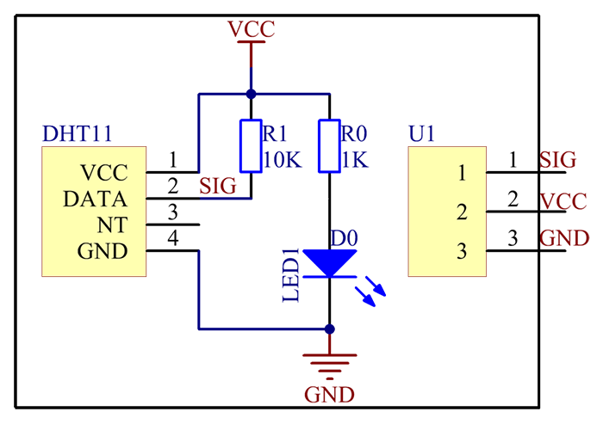  
Only three pins are available for use: VCC, GND, and DATA. The communication process begins with the DATA line sending start signals to DHT11, and DHT11 receives the signals and returns an answer signal. Then the host receives the answer signal and begins to receive 40-bit humiture data (8-bit humidity integer + 8-bit humidity decimal + 8-bit temperature integer + 8-bit temperature decimal + 8-bit checksum).  
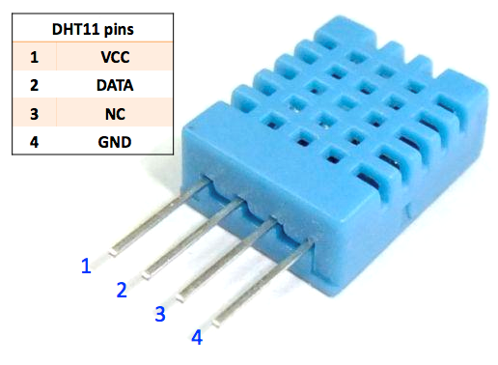

**Features**

1) A humiture sensor module to test temperature and humidity, which uses the sensor DHT11.  
2) Humidity measurement range: 20 - 90%RH  
3) Temperature measurement range: 0 - 60℃  
4) Output digital signals indicating temperature and humidity  
5) Working voltage:DC 5V; PCB size: 2.0 x 2.0 cm  
6) Humidity measurement accuracy: ±5%RH  
7) Temperature measurement accuracy: ±2℃

**Application**

The module can be applied to measurement of ambient humidity and temperature.

4.1.3 LCD DISPLAY:-

A liquid-crystal display (LCD) is a flat-panel display or other electronically modulated optical device that uses the light-modulating properties of liquid crystals combined with polarizers. Liquid crystals do not emit light directly, instead using a backlight or reflector to produce images in color or monochrome. LCDs are available to display arbitrary images (as in a general-purpose computer display) or fixed images with low information content, which can be displayed or hidden, such as preset words, digits, and seven-segment displays, as in a digital clock. They use the same basic technology, except that arbitrary images are made from a matrix of small pixels, while other displays have larger elements. LCDs can either be normally on (positive) or off (negative), depending on the polarizer arrangement. For example, a character positive LCD with a backlight will have black lettering on a background that is the color of the backlight, and a character negative LCD will have a black background with the letters being of the same color as the backlight. Optical filters are added to white on blue LCDs to give them their characteristic appearance.

LCDs are used in a wide range of applications, including LCD televisions, computer monitors, instrument panels, aircraft cockpit displays, and indoor and outdoor signage. Small LCD screens are common in LCD projectors and portable consumer devices such as digital cameras, watches, digital clocks, calculators, and mobile telephones, including smartphones. LCD screens are also used on consumer electronics products such as DVD players, video game devices and clocks. LCD screens have replaced heavy, bulky cathode ray tube (CRT) displays in nearly all applications. LCD screens are available in a wider range of screen sizes than CRT and plasma displays, with LCD screens available in sizes ranging from tiny digital watches to very large television receivers. LCDs are slowly being replaced by OLEDs, which can be easily made into different shapes, and have a lower response time, wider color gamut, virtually infinite color contrast and viewing angles, lower weight for a given display size and a slimmer profile (because OLEDs use a single glass or plastic panel whereas LCDs use two glass panels; the thickness of the panels increases with size but the increase is more noticeable on LCDs) and potentially lower power consumption (as the display is only "on" where needed and there is no backlight). OLEDs, however, are more expensive for a given display size due to the very expensive electroluminescent materials or phosphors that they use. Also due to the use of phosphors, OLEDs suffer from screen burn-in and there is currently no way to recycle OLED displays, whereas LCD panels can be recycled, although the technology required to recycle LCDs is not yet widespread. Attempts to maintain the competitiveness of LCDs are quantum dot displays, marketed as SUHD, QLED or Triluminos, which are LCD displays with blue LED backlighting and a Quantum-dot enhancement film (QDEF) that converts part of the blue light into red and green, offering similar performance to an OLED display at a lower price, but the quantum dot layer that gives these displays their characteristics can not yet be recycled.

Since LCD screens do not use phosphors, they rarely suffer image burn-in when a static image is displayed on a screen for a long time, e.g., the table frame for an airline flight schedule on an indoor sign. LCDs are, however, susceptible to image persistence.[[3]](https://en.wikipedia.org/wiki/Liquid-crystal_display#cite_note-Fujitsu-3) The LCD screen is more energy-efficient and can be disposed of more safely than a CRT can. Its low electrical power consumption enables it to be used in battery-powered electronic equipment more efficiently than a CRT can be. By 2008, annual sales of televisions with LCD screens exceeded sales of CRT units worldwide, and the CRT became obsolete for most purposes.

4.1.4 POTENTIOMETER:-

A potentiometer is a three-terminal resistor with a sliding or rotating contact that forms an adjustable voltage divider.[[1]](https://en.wikipedia.org/wiki/Potentiometer#cite_note-1) If only two terminals are used, one end and the wiper, it acts as a variable resistor or rheostat.

The measuring instrument called a potentiometer is essentially a voltage divider used for measuring electric potential (voltage); the component is an implementation of the same principle, hence its name.

Potentiometers are commonly used to control electrical devices such as volume controls on audio equipment. Potentiometers operated by a mechanism can be used as position transducers, for example, in a joystick. Potentiometers are rarely used to directly control significant power (more than a watt), since the power dissipated in the potentiometer would be comparable to the power in the controlled load.

4.1.5 JUMPER WIRES:-

A jump wire (also known as jumper, jumper wire, jumper cable, DuPont wire or cable) is an electrical wire, or group of them in a cable, with a connector or pin at each end (or sometimes without them – simply "tinned"), which is normally used to interconnect the components of a breadboard or other prototype or test circuit, internally or with other equipment or components, without soldering.[[1]](https://en.wikipedia.org/wiki/Jump_wire#cite_note-1)

Individual jump wires are fitted by inserting their "end connectors" into the slots provided in a breadboard, the header connector of a circuit board, or a piece of test equipment.

There are different types of jumper wires. Some have the same type of electrical connector at both ends, while others have different connectors. Some common connectors are:

* Solid tips – are used to connect on/with a breadboard or female header connector. The arrangement of the elements and ease of insertion on a breadboard allows increasing the mounting density of both components and jump wires without fear of short-circuits. The jump wires vary in size and colour to distinguish the different working signals.
* Crocodile clips – are used, among other applications, to temporarily bridge sensors, buttons and other elements of prototypes with components or equipment that have arbitrary connectors, wires, screw terminals, etc.
* Banana connectors – are commonly used on test equipment for DC and low-frequency AC signals.
* [Registered jack](https://en.wikipedia.org/wiki/Registered_jack) (RJnn) – are commonly used in telephone (RJ11) and computer networking (RJ45).
* RCA connectors – are often used for audio, low-resolution composite video signals, or other low-frequency applications requiring a shielded cable.
* RF connectors – are used to carry radio frequency signals between circuits, test equipment, and antennas.
* RF jumper cables - Jumper cables is a smaller and more bendable corrugated cable which is used to connect antennas and other components to network cabling. Jumpers are also used in base stations to connect antennas to radio units. Usually the most bendable jumper cable diameter is 1/2".

4.1.6 BREADBOARD:-

A breadboard, or protoboard, is a construction base for prototyping of electronics. Originally the word referred to a literal bread board, a polished piece of wood used for slicing bread. In the 1970s the solderless breadboard (a.k.a. plugboard, a terminal array board) became available and nowadays the term "breadboard" is commonly used to refer to these.

Because the solderless breadboard does not require soldering, it is reusable. This makes it easy to use for creating temporary prototypes and experimenting with circuit design. For this reason, solderless breadboards are also popular with students and in technological education. Older breadboard types did not have this property. A stripboard (Veroboard) and similar prototyping printed circuit boards, which are used to build semi-permanent soldered prototypes or one-offs, cannot easily be reused. A variety of electronic systems may be prototyped by using breadboards, from small analog and digital circuits to complete central processing units (CPUs).

Compared to more permanent circuit connection methods, modern breadboards have high parasitic capacitance, relatively high resistance, and less reliable connections, which are subject to jostle and physical degradation. Signaling is limited to about 10 MHz, and not everything works properly even well below that frequency.

A common use in the system on a chip (SoC) era is to obtain an microcontroller (MCU) on a pre-assembled printed circuit board (PCB) which exposes an array of input/output (IO) pins in a header suitable to plug into a breadboard, and then to prototype a circuit which exploits one or more of the MCU's peripherals, such as general-purpose input/output (GPIO), UART/[USART](https://en.wikipedia.org/wiki/USART) serial transceivers, analog-to-digital converter (ADC), digital-to-analog converter (DAC), pulse-width modulation (PWM; used in motor control), Serial Peripheral Interface (SPI), or [I²C](https://en.wikipedia.org/wiki/I%C2%B2C).

Firmware is then developed for the MCU to test, debug, and interact with the circuit prototype. High frequency operation is then largely confined to the SoC's PCB. In the case of high speed interconnects such as SPI and I²C, these can be debugged at a lower speed and later rewired using a different circuit assembly methodology to exploit full-speed operation. A single small SoC often provides most of these electrical interface options in a form factor barely larger than a large postage stamp, available in the American hobby market (and elsewhere) for a few dollars, allowing fairly sophisticated breadboard projects to be created at modest expense.

4.1.7 ARDUINO UNO:-

The Arduino Uno is an open-source microcontroller board based on the [Microchip](https://en.wikipedia.org/wiki/Microchip_Technology) ATmega328P microcontroller and developed by Arduino.cc.[[2]](https://en.wikipedia.org/wiki/Arduino_Uno#cite_note-2)[[3]](https://en.wikipedia.org/wiki/Arduino_Uno#cite_note-What_is_Arduino?-3) The board is equipped with sets of digital and analog input/output (I/O) pins that may be interfaced to various expansion boards (shields) and other circuits.[[1]](https://en.wikipedia.org/wiki/Arduino_Uno#cite_note-Makerspace-1) The board has 14 digital I/O pins (six capable of [PWM](https://en.wikipedia.org/wiki/Pulse-width_modulation) output), 6 analog I/O pins, and is programmable with the [Arduino IDE](https://en.wikipedia.org/wiki/Arduino#Software) (Integrated Development Environment), via a type B [USB cable](https://en.wikipedia.org/wiki/USB_cable).[[4]](https://en.wikipedia.org/wiki/Arduino_Uno#cite_note-princeton-4) It can be powered by the USB cable or by an external 9-volt battery, though it accepts voltages between 7 and 20 volts. It is similar to the [Arduino Nano](https://en.wikipedia.org/wiki/Arduino_Nano) and Leonardo.[[5]](https://en.wikipedia.org/wiki/Arduino_Uno#cite_note-5)[[6]](https://en.wikipedia.org/wiki/Arduino_Uno#cite_note-6) The hardware reference design is distributed under a [Creative Commons](https://en.wikipedia.org/wiki/Creative_Commons) Attribution Share-Alike 2.5 license and is available on the Arduino website. Layout and production files for some versions of the hardware are also available.

The word "[uno](https://en.wiktionary.org/wiki/uno)" means "one" in [Italian](https://en.wikipedia.org/wiki/Italian_language) and was chosen to mark the initial release of [Arduino Software](https://en.wikipedia.org/wiki/Arduino_Software).[[1]](https://en.wikipedia.org/wiki/Arduino_Uno#cite_note-Makerspace-1) The Uno board is the first in a series of USB-based Arduino boards;[[3]](https://en.wikipedia.org/wiki/Arduino_Uno#cite_note-What_is_Arduino?-3) it and version 1.0 of the Arduino [IDE](https://en.wikipedia.org/wiki/Integrated_development_environment) were the reference versions of Arduino, which have now evolved to newer releases.[[4]](https://en.wikipedia.org/wiki/Arduino_Uno#cite_note-princeton-4) The ATmega328 on the board comes preprogrammed with a [bootloader](https://en.wikipedia.org/wiki/Bootloader) that allows uploading new code to it without the use of an external hardware programmer.[[3]](https://en.wikipedia.org/wiki/Arduino_Uno#cite_note-What_is_Arduino?-3)

While the Uno communicates using the original STK500 protocol,[[1]](https://en.wikipedia.org/wiki/Arduino_Uno#cite_note-Makerspace-1) it differs from all preceding boards in that it does not use the FTDI USB-to-serial driver chip. Instead, it uses the Atmega16U2 (Atmega8U2 up to version R2) programmed as a [USB-to-serial converter](https://en.wikipedia.org/wiki/USB-to-serial_converter).[[7]](https://en.wikipedia.org/wiki/Arduino_Uno#cite_note-website-7)

4.2 DATA DESIGN:

* Database design is the organization of data according to a database model.
* The designer determines what the data must be stored and how the data elements interrelate.
* With this information they could fit the data to a database model.
* Database management system manages the data accordingly.

4.3 SCHEMA DESIGN:

* The term “schema” refers to the organization of data as a blueprint of how the database is constructed.
* The formal definition of a database schema is a set of formulas called integrity constraints imposed on a database.
* These integrity constraints ensure compatibility between parts of the schema.
* All constraints are expressible in the same language.
* A database schema specifies based on the database administrator’s knowledge of possible applications the facts that can enter the database or those of interest to the possible end-users.
* The notion of a database schema plays the same role as the notion of the theory in predicate calculus.
* Thus a schema can contain formulas representing integrity constraints specifically for an application and the constraints specifically for a type of database all expressed in the same database language.
* In a relational database schema defines the tables, fields, functions, procedures, triggers, database links, directories.
* A database stores its schema in a data dictionary.

4.4 DATA INTEGRITY AND CONSTRAINTS:

* Integrity and constraints are a set of rules.
* It is used to maintain the quality of information.
* Integrity constraints ensure that the data insertion, updating and other processes have to be performed in such a way that data integrity is not affected.
* Integrity constraints is used to guard against accidental damage to the database.
* Types of integrity constraints: -
* Domain constraints:
* Domain constraints can be defined as the definition of a valid set of values for an attribute.
* Entity integrity constraints:
* The entity integrity constraints states that primary key value can’t be null.
* Referential integrity constraints:
* A referential integrity constraints is specified between two tables.
* Key constraints:
* Keys are the entity set that is used to identify an entity within its entity set uniquely.

4.5 PROCEDURAL DESIGN:

* Converts and translates structural elements into procedural explanations.
* Procedural design starts straight after data design and architectural design.
* This has now been mostly abandoned mostly due to the rise in preference of object oriented programming and design patterns.

4.6 LOGIC DESIGN:

* Logic design is the basic organization of the circuitry of a digital computer.
* All digital computers are based on a two valued logic system – 1/0, on/off, yes/no.
* Computers perform calculations using components called logic gates, which are made up of integrated circuits that receive an input signal, process it, and change it into an output signal.

4.7 DATA STRUCTURES:

* Data structure is a data organization, management, and storage format that enables efficient access and modification.
* More precisely, a data structure is a collection of data values, the relationship among them, and the functions or operations that can be applied to the data.
* Data structures are generally based on the ability of a computer to fetch and store data at any place in its memory.
* The implementation of data structures usually requires writing a set of procedures that create and manipulates instances of that structure.
* The efficiency of a data structure cannot be analyzed separately from those operations.

4.8 ALGORITHM DESIGN:

* Algorithm is a finite sequence of well defined computer implementable instructions, typically to solve a class of problems or to perform a computation.
* Algorithms are always unambiguous and are used as specifications for performing calculations, data processing. Automated reasoning and various other tasks.
* As an effective method an algorithm can be expressed within a finite amount of space and time, and in a well-defined formal language for calculating a function.
* Algorithm design refers to a method or a mathematical process for problem solving and engineering algorithms.
* The design of algorithm is part of many solution theories of operation research, such as dynamic programming and divide and conquer.
* Techniques for designing and implementing algorithm designs are also called algorithm design patterns.
* One of the most important aspects of algorithm design lies in the creation of algorithm that has an efficient run-time, also known as its Big-O.

4.9 USER INTERFACE DESIGN:

* User interface design or user interface engineering is the design of user interfaces for machines and software such as computers, home appliances, mobile devices, and other electronic devices with the focus on maximizing usability and the user experience.
* The goal of user interface design is to make the user’s interaction as simple and efficient as possible, in terms of accomplishing user goals.
* Good user interface design facilitates finishing the task at hand without drawing unnecessary attention to itself.
* The design process must balance technical functionality and visual elements to create a system that is not only operational but also usable and adaptable to changing user needs.
* Interface design is involved in a wide range of projects, from computer systems, to cars, to commercial planes, all of these projects involve much of the same.
* As a result, designers tend to specialize in certain types of projects and have skills centered on their expertise, whether it is a software design, user research, web design, industrial design.
* User interface design requires a good understanding of user needs.
* It mainly focuses on the needs of the platform and its user expectations.

4.10 SECURITY ISSUES:

* Employee are the biggest security threat to a project.
* According to statistics, employees often fall victim to ransomware and phishing attacks frequently.
* More than 90% of attacks can be traced down to a particular employee.
* Vishing involves the use of phone calls to carry out an attack.
* The only remedy is to provide information security training and instituting policies that prevents the sharing of information via phone calls.

4.11 TEST CASE DESIGN:

* Test case design refers to how you set up your test cases.
* It is important that your tests are designed well, or you could fail to identify bugs and defects in your software during testing.
* There are many different test case design techniques used to test the functionality and various features of your software.
* Designing good test cases ensure that every aspect of your software gets tested so that you can find and fix any issues.
* The main purpose of test case design techniques is to test the functionalities and features of the software with the help of effective test cases.
* The successful application of test case design techniques will render test cases that ensure the success of software testing.
  1. ARDUINO CODE:-

CODE 1:-

#include <dht.h>

#include <LiquidCrystal.h>

LiquidCrystal LCD(10, 9, 5, 4, 3, 2);

#define dht_apin A1 // sensor is connected to Analog Pin

dht DHT;

void setup()

{

Serial.begin(9600);

pinMode(A0, INPUT);

LCD.begin(16,2);

}

void loop()

{

int SensorValue= analogRead(A0);

Serial.print(SensorValue);

Serial.print(" - ");

if(SensorValue >= 1000)

{

Serial.println("not in Soil or DISCONNECTED");

LCD.setCursor(0,0);

LCD.print("NOT IN SOIL");

LCD.print(" ");

}

if(SensorValue < 1000 && SensorValue >= 600)

{

Serial.println("DRY");

LCD.setCursor(0,0);

LCD.print("DRY");

LCD.print(" ");

}

if(SensorValue < 600 && SensorValue >= 370)

{

Serial.println("HUMID");

LCD.setCursor(0,0);

LCD.print("HUMID");

LCD.print(" ");

}

if(SensorValue < 370)

{

Serial.println("WATER");

LCD.setCursor(0,0);

LCD.print("WATER");

LCD.print(" ");

}

LCD.setCursor(0,1);

LCD.print(" ");

LCD.setCursor(0,1);

LCD.print(SensorValue);

delay(1000);delay(2000); //wait a sec (recommended for DHT11)

DHT.read11(dht_apin);

LCD.clear();

LCD.setCursor(0,0);

LCD.print("Humidity: ");

LCD.print(DHT.humidity);

LCD.print("%");

LCD.setCursor(0,1);

LCD.print("Temp: ");

LCD.print(DHT.temperature);

LCD.setCursor(12,1);

LCD.print( (char)223); // displaying degree symbol (°).

LCD.print("C");

}

}

CODE 2:-

#include <Wire.h>

#include <Adafruit_Sensor.h>

#include "Adafruit_BME680.h"

#define SEALEVELPRESSURE_HPA (1013.25)

Adafruit_BME680 bme; // I2C

void setup()

{

Serial.begin(9600);

while (!Serial);

Serial.println(F("BME680 test"));

if (!bme.begin())

{

Serial.println("Could not find a valid BME680 sensor, check wiring!");

while (1);

}

// Set up oversampling and filter initialization

bme.setTemperatureOversampling(BME680_OS_8X);

bme.setHumidityOversampling(BME680_OS_2X);

bme.setPressureOversampling(BME680_OS_4X);

bme.setIIRFilterSize(BME680_FILTER_SIZE_3);

bme.setGasHeater(320, 150); // 320*C for 150 ms

}

void loop()

{

if (! bme.performReading())

{

Serial.println("Failed to perform reading :(");

return;

}

float temperature = bme.temperature;

float pressure = bme.pressure / 100.0;

float altitude = bme.readAltitude(SEALEVELPRESSURE_HPA);

float humidity = bme.humidity;

float gas = bme.gas_resistance / 1000.0;

double dewPoint = dewPointFast(temperature, humidity);

Serial.print("Temperature = ");

Serial.print(temperature);

Serial.println(" *C");

Serial.print("Pressure = ");

Serial.print(pressure);

Serial.println(" hPa");

Serial.print("Humidity = ");

Serial.print(humidity);

Serial.println(" %");

Serial.print("Dew Point = ");

Serial.print(dewPoint);

Serial.println(" *C");

Serial.print("Approx. Altitude = ");

Serial.print(altitude);

Serial.println(" m");

Serial.print("Gas = ");

Serial.print(gas);

Serial.println(" KOhms");

Serial.println();

delay(2000);

}

double dewPointFast(double celsius, double humidity)

{

double a = 17.271;

double b = 237.7;

double temp = (a * celsius) / (b + celsius) + log(humidity * 0.01);

double Td = (b * temp) / (a - temp);

return Td;

}

CODE 3:-

#include <Wire.h>

#include <SPI.h>

#include <Adafruit_Sensor.h>

#include "Adafruit_BME680.h"

#define BME_SCK 13

#define BME_MISO 12

#define BME_MOSI 11

#define BME_CS 10

#define SEALEVELPRESSURE_HPA (1013.25)

Adafruit_BME680 bme(BME_CS, BME_MOSI, BME_MISO, BME_SCK);

void setup() {

Serial.begin(115200);

while (!Serial);

Serial.println(F("BME680 async test"));

if (!bme.begin()) {

Serial.println(F("Could not find a valid BME680 sensor, check wiring!"));

while (1);

}

// Set up oversampling and filter initialization

bme.setTemperatureOversampling(BME680_OS_8X);

bme.setHumidityOversampling(BME680_OS_2X);

bme.setPressureOversampling(BME680_OS_4X);

bme.setIIRFilterSize(BME680_FILTER_SIZE_3);

bme.setGasHeater(320, 150); // 320*C for 150 ms

}

void loop() {

// Tell BME680 to begin measurement.

unsigned long endTime = bme.beginReading();

if (endTime == 0) {

Serial.println(F("Failed to begin reading :("));

return;

}

Serial.print(F("Reading started at "));

Serial.print(millis());

Serial.print(F(" and will finish at "));

Serial.println(endTime);

Serial.println(F("You can do other work during BME680 measurement."));

delay(50); // This represents parallel work.

// There's no need to delay() until millis() >= endTime: bme.endReading()

// takes care of that. It's okay for parallel work to take longer than

// BME680's measurement time.

// Obtain measurement results from BME680. Note that this operation isn't

// instantaneous even if milli() >= endTime due to I2C/SPI latency.

if (!bme.endReading()) {

Serial.println(F("Failed to complete reading :("));

return;

}

Serial.print(F("Reading completed at "));

Serial.println(millis());

float temperature = bme.temperature;

float pressure = bme.pressure / 100.0;

float altitude = bme.readAltitude(SEALEVELPRESSURE_HPA);

float humidity = bme.humidity;

float gas = bme.gas_resistance / 1000.0;

double dewPoint = dewPointFast(temperature, humidity);

Serial.print("Temperature = ");

Serial.print(temperature);

Serial.println(" *C");

Serial.print("Pressure = ");

Serial.print(pressure);

Serial.println(" hPa");

Serial.print("Humidity = ");

Serial.print(humidity);

Serial.println(" %");

Serial.print("Dew Point = ");

Serial.print(dewPoint);

Serial.println(" *C");

Serial.print("Approx. Altitude = ");

Serial.print(altitude);

Serial.println(" m");

Serial.print("Gas = ");

Serial.print(gas);

Serial.println(" KOhms");

Serial.println();

delay(2000);

}

double dewPointFast(double celsius, double humidity)

{

double a = 17.271;

double b = 237.7;

double temp = (a * celsius) / (b + celsius) + log(humidity * 0.01);

double Td = (b * temp) / (a - temp);

return Td;

}

CODE 4:-

#include "bsec.h"

// Helper functions declarations

void checkIaqSensorStatus(void);

void errLeds(void);

// Create an object of the class Bsec

Bsec iaqSensor;

String output;

// Entry point for the example

void setup(void)

{

Serial.begin(115200);

Wire.begin();

iaqSensor.begin(BME680_I2C_ADDR_PRIMARY, Wire);

output = "\nBSEC library version " + String(iaqSensor.version.major) + "." + String(iaqSensor.version.minor) + "." + String(iaqSensor.version.major_bugfix) + "." + String(iaqSensor.version.minor_bugfix);

Serial.println(output);

checkIaqSensorStatus();

bsec_virtual_sensor_t sensorList[10] = {

BSEC_OUTPUT_RAW_TEMPERATURE,

BSEC_OUTPUT_RAW_PRESSURE,

BSEC_OUTPUT_RAW_HUMIDITY,

BSEC_OUTPUT_RAW_GAS,

BSEC_OUTPUT_IAQ,

BSEC_OUTPUT_STATIC_IAQ,

BSEC_OUTPUT_CO2_EQUIVALENT,

BSEC_OUTPUT_BREATH_VOC_EQUIVALENT,

BSEC_OUTPUT_SENSOR_HEAT_COMPENSATED_TEMPERATURE,

BSEC_OUTPUT_SENSOR_HEAT_COMPENSATED_HUMIDITY,

};

iaqSensor.updateSubscription(sensorList, 10, BSEC_SAMPLE_RATE_LP);

checkIaqSensorStatus();

// Print the header

output = "Timestamp [ms], raw temperature [°C], pressure [hPa], raw relative humidity [%], gas [Ohm], IAQ, IAQ accuracy, temperature [°C], relative humidity [%], Static IAQ, CO2 equivalent, breath VOC equivalent";

Serial.println(output);

}

// Function that is looped forever

void loop(void)

{

unsigned long time_trigger = millis();

if (iaqSensor.run()) { // If new data is available

output = String(time_trigger);

output += ", " + String(iaqSensor.rawTemperature);

output += ", " + String(iaqSensor.pressure);

output += ", " + String(iaqSensor.rawHumidity);

output += ", " + String(iaqSensor.gasResistance);

output += ", " + String(iaqSensor.iaq);

output += ", " + String(iaqSensor.iaqAccuracy);

output += ", " + String(iaqSensor.temperature);

output += ", " + String(iaqSensor.humidity);

output += ", " + String(iaqSensor.staticIaq);

output += ", " + String(iaqSensor.co2Equivalent);

output += ", " + String(iaqSensor.breathVocEquivalent);

Serial.println(output);

} else {

checkIaqSensorStatus();

}

}

// Helper function definitions

void checkIaqSensorStatus(void)

{

if (iaqSensor.status != BSEC_OK) {

if (iaqSensor.status < BSEC_OK) {

output = "BSEC error code : " + String(iaqSensor.status);

Serial.println(output);

for (;;)

errLeds(); /* Halt in case of failure */

} else {

output = "BSEC warning code : " + String(iaqSensor.status);

Serial.println(output);

}

}

if (iaqSensor.bme680Status != BME680_OK) {

if (iaqSensor.bme680Status < BME680_OK) {

output = "BME680 error code : " + String(iaqSensor.bme680Status);

Serial.println(output);

for (;;)

errLeds(); /* Halt in case of failure */

} else {

output = "BME680 warning code : " + String(iaqSensor.bme680Status);

Serial.println(output);

}

}

}

void errLeds(void)

{

pinMode(LED_BUILTIN, OUTPUT);

digitalWrite(LED_BUILTIN, HIGH);

delay(100);

digitalWrite(LED_BUILTIN, LOW);

delay(100);

}

CODE 5:-

#include < dht.h>

#include < LiquidCrystal.h>

LiquidCrystal lcd(12, 11, 5, 4, 3, 2);

#define dht_apin A0 // sensor is connected to Analog Pin

dht DHT;

void setup()

{

lcd.begin(16,2); // LCD character display

}

void loop(){

delay(2000); //wait a sec (recommended for DHT11)

DHT.read11(dht_apin);

lcd.clear();

lcd.setCursor(0,0);

lcd.print("Humidity: ");

lcd.print(DHT.humidity);

lcd.print("%");

lcd.setCursor(0,1);

lcd.print("Temp: ");

lcd.print(DHT.temperature);

lcd.setCursor(12,1);

lcd.print( (char)223); // displaying degree symbol (°).

lcd.print("C")

}

4.13 DATABASE CODE:-

**DBHelper.java**

package com.gaurav.loginsqlite;  
import android.content.ContentValues;  
import android.content.Context;  
import android.database.Cursor;  
import android.database.sqlite.SQLiteDatabase;  
import android.database.sqlite.SQLiteOpenHelper;  
import androidx.annotation.Nullable;  
  
public class DBHelper extends SQLiteOpenHelper {  
 public static final String DBNAME = "Login.db";  
 public DBHelper(Context context) {  
 super(context, "Login.db", null, 1);  
 }  
  
 @Override  
 public void onCreate(SQLiteDatabase MyDB) {  
 MyDB.execSQL("create Table users(username TEXT primary key, password TEXT)");  
 }  
  
 @Override  
 public void onUpgrade(SQLiteDatabase MyDB, int i, int i1) {  
 MyDB.execSQL("drop Table if exists users");  
 }  
  
 public Boolean insertData(String username, String password){  
 SQLiteDatabase MyDB = this.getWritableDatabase();  
 ContentValues contentValues= new ContentValues();  
 contentValues.put("username", username);  
 contentValues.put("password", password);  
 long result = MyDB.insert("users", null, contentValues);  
 if(result==-1) return false;  
 else  
 return true;  
 }  
  
 public Boolean checkusername(String username) {  
 SQLiteDatabase MyDB = this.getWritableDatabase();  
 Cursor cursor = MyDB.rawQuery("Select * from users where username = ?", new String[]{username});  
 if (cursor.getCount() > 0)  
 return true;  
 else  
 return false;  
 }  
  
 public Boolean checkusernamepassword(String username, String password){  
 SQLiteDatabase MyDB = this.getWritableDatabase();  
 Cursor cursor = MyDB.rawQuery("Select * from users where username = ? and password = ?", new String[] {username,password});  
 if(cursor.getCount()>0)  
 return true;  
 else  
 return false;  
 }  
}

**MainActivity.java**

package com.gaurav.loginsqlite;  
import androidx.appcompat.app.AppCompatActivity;  
import android.content.Intent;  
import android.os.Bundle;  
import android.view.View;  
import android.widget.Button;  
import android.widget.EditText;  
import android.widget.Toast;  
  
public class MainActivity extends AppCompatActivity {  
  
 EditText username, password, repassword;  
 Button signup, signin;  
 DBHelper DB;  
 boolean isPasswordValid,isUserValid,isRepasswordValid;  
  
 @Override  
 protected void onCreate(Bundle savedInstanceState) {  
 super.onCreate(savedInstanceState);  
 setContentView(R.layout.*activity_main*);  
  
 username = (EditText) findViewById(R.id.*username*);  
 password = (EditText) findViewById(R.id.*password*);  
 repassword = (EditText) findViewById(R.id.*repassword*);  
 signup = (Button) findViewById(R.id.*btnsignup*);  
 signin = (Button) findViewById(R.id.*btnsignin*);  
 DB = new DBHelper(this);  
  
 signup.setOnClickListener(new View.OnClickListener() {  
 @Override  
 public void onClick(View view) {  
  
 SetValidation();  
 if(SetValidation()){  
  
 String user = username.getText().toString();  
 String pass = password.getText().toString();  
 String repass = repassword.getText().toString();  
  
 if(user.equals("")||pass.equals("")||repass.equals(""))  
 Toast.*makeText*(MainActivity.this, "Please enter all the fields", Toast.*LENGTH_SHORT*).show();  
 else{  
 if(pass.equals(repass)){  
 Boolean checkuser = DB.checkusername(user);  
 if(checkuser==false){  
 Boolean insert = DB.insertData(user, pass);  
 if(insert==true){  
 Toast.*makeText*(MainActivity.this, "Registered successfully", Toast.*LENGTH_SHORT*).show();  
 Intent intent = new Intent(getApplicationContext(),HomeActivity.class);  
 startActivity(intent);  
 }else{  
 Toast.*makeText*(MainActivity.this, "Registration failed", Toast.*LENGTH_SHORT*).show();  
 }  
 }  
 else{  
 Toast.*makeText*(MainActivity.this, "User already exists! please sign in", Toast.*LENGTH_SHORT*).show();  
 }  
 }else{  
 Toast.*makeText*(MainActivity.this, "Passwords not matching", Toast.*LENGTH_SHORT*).show();  
 }  
 } }}  
 });  
  
 signin.setOnClickListener(new View.OnClickListener() {  
 @Override  
 public void onClick(View view) {  
 Intent intent = new Intent(getApplicationContext(), LoginActivity.class);  
 startActivity(intent);  
 }  
 });  
 }  
  
private boolean SetValidation() {  
  
 if(username.getText().toString().isEmpty()){  
 username.setError(getResources().getString(R.string.*name_error*));  
 isUserValid=false;  
 }  
 else if(username.getText().length()<5){  
 username.setError(getResources().getString(R.string.*name_error1*));  
 // Toast.makeText(this, "password must be upto 6 character", Toast.LENGTH_SHORT).show();  
 isUserValid=false;  
  
 }else if(username.getText().toString().contains(" ")){  
  
 username.setError(getResources().getString(R.string.*name_error2*));  
 isUserValid=false;  
 }else{  
  
 isUserValid=true;  
 }  
  
 if(password.getText().toString().isEmpty()){  
 password.setError(getResources().getString(R.string.*password_error*));  
 isPasswordValid=false;  
 }  
 else if(password.getText().length()<6){  
 password.setError(getResources().getString(R.string.*error_invalid_password*));  
 isPasswordValid=false;  
  
 } else{  
  
 isPasswordValid=true;  
 }  
  
 String repass =repassword.getText().toString();  
 if(repass.equals(password.getText().toString())){  
 isRepasswordValid= true;  
  
 }else{  
 repassword.setError(getResources().getString(R.string.*error_invalid_repassword*));  
 isRepasswordValid = false;  
 }  
  
  
  
 if(isUserValid && isPasswordValid && isRepasswordValid){  
 Toast.*makeText*(this, "Successfully", Toast.*LENGTH_SHORT*).show();  
 return true;  
 }  
 return false;  
 }  
  
}

**activity_main.xml**

<?xml version="1.0" encoding="utf-8"?>  
<RelativeLayout xmlns:android="http://schemas.android.com/apk/res/android"  
 xmlns:app="http://schemas.android.com/apk/res-auto"  
 xmlns:tools="http://schemas.android.com/tools"  
 android:layout_width="match_parent"  
 android:layout_height="match_parent"  
 android:padding="10dp"  
 android:background="@drawable/pic4"  
 tools:context=".MainActivity">  
  
 <EditText  
 android:id="@+id/username"  
 android:layout_width="match_parent"  
 android:layout_height="wrap_content"  
 android:hint="User Name"  
 android:layout_marginTop="50dp"/>  
  
  
 <EditText  
 android:id="@+id/password"  
 android:layout_width="match_parent"  
 android:layout_height="wrap_content"  
 android:hint="Password"  
 android:layout_marginTop="50dp"  
 android:layout_below="@+id/username"/>  
  
  
 <EditText  
 android:id="@+id/repassword"  
 android:layout_width="match_parent"  
 android:layout_height="wrap_content"  
 android:hint="Retype Password"  
 android:layout_marginTop="50dp"  
 android:layout_below="@+id/password"/>  
  
  
 <Button  
 android:id="@+id/btnsignup"  
 android:layout_width="match_parent"  
 android:layout_height="wrap_content"  
 android:text="Register"  
 android:layout_marginTop="50dp"  
 android:layout_below="@+id/repassword"/>  
  
 <Button  
 android:id="@+id/btnsignin"  
 android:layout_width="match_parent"  
 android:layout_height="wrap_content"  
 android:text="Existing user ! Go to sign in page"  
 android:layout_marginTop="50dp"  
 android:layout_below="@+id/btnsignup"/>  
  
  
  
</RelativeLayout>

**LoginActivity.java**

package com.gaurav.loginsqlite;  
import androidx.appcompat.app.AppCompatActivity;  
  
import android.content.Intent;  
import android.os.Bundle;  
import android.view.View;  
import android.widget.Button;  
import android.widget.EditText;  
import android.widget.Toast;  
  
public class LoginActivity extends AppCompatActivity {  
 EditText username, password;  
 Button btnlogin;  
 DBHelper DB;  
 @Override  
 protected void onCreate(Bundle savedInstanceState) {  
 super.onCreate(savedInstanceState);  
 setContentView(R.layout.*activity_login*);  
  
 username = (EditText) findViewById(R.id.*username1*);  
 password = (EditText) findViewById(R.id.*password1*);  
 btnlogin = (Button) findViewById(R.id.*btnsignin1*);  
 DB = new DBHelper(this);  
  
 btnlogin.setOnClickListener(new View.OnClickListener() {  
 @Override  
 public void onClick(View view) {  
  
 String user = username.getText().toString();  
 String pass = password.getText().toString();  
  
 if(user.equals("")||pass.equals(""))  
 Toast.*makeText*(LoginActivity.this, "Please enter all the fields", Toast.*LENGTH_SHORT*).show();  
 else{  
 Boolean checkuserpass = DB.checkusernamepassword(user, pass);  
 if(checkuserpass==true){  
 Toast.*makeText*(LoginActivity.this, "Sign in successfull", Toast.*LENGTH_SHORT*).show();  
 Intent intent = new Intent(getApplicationContext(), HomeActivity.class);  
 startActivity(intent);  
 }else{  
 Toast.*makeText*(LoginActivity.this, "Invalid Credentials", Toast.*LENGTH_SHORT*).show();  
 }  
 }  
 }  
 });  
 }  
}

**activity_login.xml**

<?xml version="1.0" encoding="utf-8"?>  
<RelativeLayout xmlns:android="http://schemas.android.com/apk/res/android"  
 xmlns:app="http://schemas.android.com/apk/res-auto"  
 xmlns:tools="http://schemas.android.com/tools"  
 android:layout_width="match_parent"  
 android:layout_height="match_parent"  
 android:padding="10dp"  
 android:background="@drawable/pic4"  
 tools:context=".LoginActivity">  
  
  
 <EditText  
 android:id="@+id/username1"  
 android:layout_width="match_parent"  
 android:layout_height="wrap_content"  
 android:hint="User Name"  
 android:layout_marginTop="50dp"/>  
  
  
 <EditText  
 android:id="@+id/password1"  
 android:layout_width="match_parent"  
 android:layout_height="wrap_content"  
 android:hint="Password"  
 android:layout_marginTop="50dp"  
 android:layout_below="@+id/username1"/>  
  
  
 <Button  
 android:id="@+id/btnsignin1"  
 android:layout_width="match_parent"  
 android:layout_height="wrap_content"  
 android:text="Sign in"  
 android:layout_marginTop="50dp"  
 android:layout_below="@+id/password1"/>  
  
</RelativeLayout>

**HomeActivity.java**

package com.gaurav.loginsqlite;  
  
import androidx.appcompat.app.AppCompatActivity;  
  
import android.graphics.Color;  
import android.os.Bundle;  
import android.view.View;  
import android.widget.EditText;  
import android.widget.TextView;  
import android.widget.Toast;  
  
import com.android.volley.Request;  
import com.android.volley.RequestQueue;  
import com.android.volley.Response;  
import com.android.volley.VolleyError;  
import com.android.volley.toolbox.JsonObjectRequest;  
import com.android.volley.toolbox.Volley;  
  
import org.json.JSONArray;  
import org.json.JSONException;  
import org.json.JSONObject;  
  
import java.util.Map;  
  
@SuppressWarnings({"ALL", "SyntaxError"})  
public class HomeActivity extends AppCompatActivity {  
 EditText et;  
 TextView tv;  
 //private Object view;  
  
 @Override  
 protected void onCreate(Bundle savedInstanceState) {  
 super.onCreate(savedInstanceState);  
 setContentView(R.layout.*activity_home*);  
 et = findViewById(R.id.*et*);  
 tv = findViewById(R.id.*tv*);  
 }  
  
 public void get(View view, String output) {  
 String apikey = " 6ec9ac7be43d11995518f4c8b050955c";  
 String city = et.getText().toString();  
 String url = "https://api.openweathermap.org/data/2.5/weather?q="+city+"&appid=6ec9ac7be43d11995518f4c8b050955c";  
 RequestQueue queue = Volley.*newRequestQueue*(getApplicationContext());  
 JsonObjectRequest request = new JsonObjectRequest(Request.Method.*GET*, url,null, new Response.Listener<JSONObject>() {  
 @Override  
 public void onResponse(JSONObject response) {  
  
 try {  
  
 JSONObject object = response.getJSONObject("main");  
 String temprature = object.getString("temp");  
 Double temp = Double.*parseDouble*(temprature) - 273.15;  
 tv.setText("Temprature : " + temp.toString()+" Celsius");  
  
  
  
  
  
 } catch (JSONException e) {  
 Toast.*makeText*(HomeActivity.this, "Check City Name", Toast.*LENGTH_SHORT*).show();  
 }  
 }  
 }, new Response.ErrorListener() {  
 @Override  
 public void onErrorResponse(VolleyError error) {  
 Toast.*makeText*(HomeActivity.this, "Please enter a valid city", Toast.*LENGTH_SHORT*).show();  
 }  
 });  
 queue.add(request);  
  
 }  
  
 public void get(View view) {  
 }  
}

**activity_home.xml**

<?xml version="1.0" encoding="utf-8"?>  
<LinearLayout xmlns:android="http://schemas.android.com/apk/res/android"  
 xmlns:app="http://schemas.android.com/apk/res-auto"  
 xmlns:tools="http://schemas.android.com/tools"  
 android:layout_width="match_parent"  
 android:layout_height="match_parent"  
 android:layout_marginStart="15dp"  
 android:layout_marginLeft="15dp"  
 android:background="@drawable/pic6"  
 android:orientation="vertical"  
 android:padding="20dp"  
 tools:context=".HomeActivity">  
  
  
  
 <EditText  
 android:id="@+id/editTextTextPersonName"  
 android:layout_width="match_parent"  
 android:layout_height="wrap_content"  
 android:layout_gravity="center_horizontal"  
 android:layout_marginTop="30dp"  
 android:ems="10"  
 android:inputType="textPersonName"  
 android:text="Weather Update"  
 android:textSize="40sp"  
 android:textStyle="bold" />  
  
 <EditText  
 android:id="@+id/et"  
 android:layout_width="match_parent"  
 android:layout_height="wrap_content"  
 android:layout_gravity="center_horizontal"  
 android:layout_marginTop="30dp"  
 android:ems="10"  
 android:hint="@string/hint"  
 android:inputType="textPersonName"  
 android:text=" "  
 android:textColorHighlight="#FFFFFF"  
 android:textColorHint="#090808" />  
  
 <Button  
 android:id="@+id/button"  
 android:layout_width="match_parent"  
 android:layout_height="wrap_content"  
 android:layout_gravity="center_horizontal"  
 android:layout_marginTop="30dp"  
 android:onClick="get"  
 android:text="Check"  
 android:textSize="20sp"  
 tools:ignore="OnClick" />  
  
 <TextView  
 android:id="@+id/tv"  
 android:layout_width="match_parent"  
 android:layout_height="204dp"  
 android:layout_gravity="center_horizontal"  
 android:layout_marginTop="30dp"  
 android:text=" hiiiiii"  
 android:textSize="20sp" />  
 </LinearLayout>

**AndroidManifest.xml**

<?xml version="1.0" encoding="utf-8"?>  
<manifest xmlns:android="http://schemas.android.com/apk/res/android"  
 package="com.gaurav.loginsqlite">  
 <uses-permission android:name="android.permission.INTERNET"/>  
  
  
 <application  
 android:allowBackup="true"  
 android:icon="@mipmap/ic_launcher"  
 android:label="@string/app_name"  
 android:roundIcon="@mipmap/ic_launcher_round"  
 android:supportsRtl="true"  
 android:theme="@style/Theme.Loginsqlite">  
  
 <activity android:name=".HomeActivity"></activity>  
 <activity android:name=".LoginActivity" />  
 <activity android:name=".MainActivity">  
 <intent-filter>  
 <action android:name="android.intent.action.MAIN" />  
  
 <category android:name="android.intent.category.LAUNCHER" />  
 </intent-filter>  
 </activity>  
 </application>  
  
</manifest>

**Build.gradle**

plugins **{** id 'com.android.application'  
**}**android **{** compileSdkVersion 30  
 buildToolsVersion "30.0.3"  
  
 defaultConfig **{** applicationId "com.gaurav.loginsqlite"  
 minSdkVersion 16  
 targetSdkVersion 30  
 versionCode 1  
 versionName "1.0"  
  
 testInstrumentationRunner "androidx.test.runner.AndroidJUnitRunner"  
 **}** buildTypes **{** release **{** minifyEnabled false  
 proguardFiles getDefaultProguardFile('proguard-android-optimize.txt'), 'proguard-rules.pro'  
 **}  
 }** compileOptions **{** sourceCompatibility JavaVersion.*VERSION_1_8* targetCompatibility JavaVersion.*VERSION_1_8* **}  
}**dependencies **{** implementation 'androidx.appcompat:appcompat:1.2.0'  
 implementation 'com.google.android.material:material:1.3.0'  
 implementation 'androidx.constraintlayout:constraintlayout:2.0.4'  
 testImplementation 'junit:junit:4.+'  
 androidTestImplementation 'androidx.test.ext:junit:1.1.2'  
 androidTestImplementation 'androidx.test.espresso:espresso-core:3.3.0'  
 implementation 'com.android.volley:volley:1.2.0'  
  
**}**

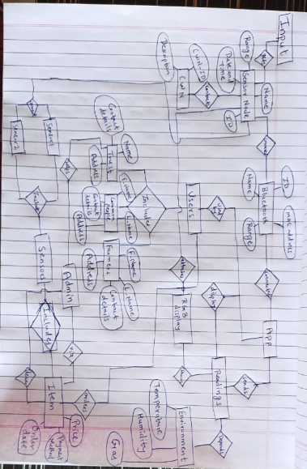

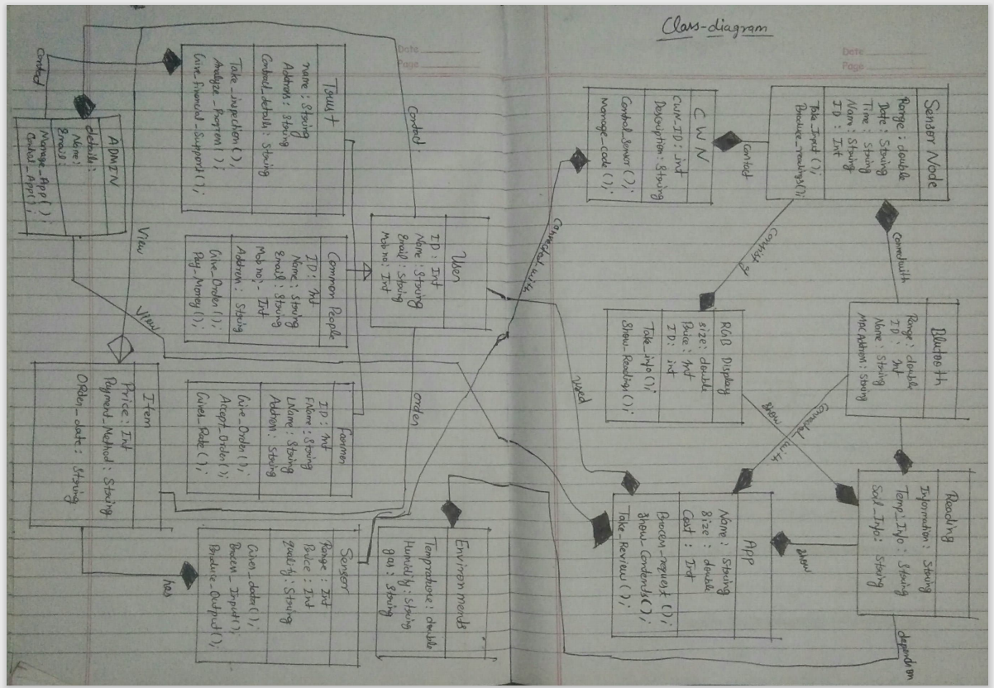

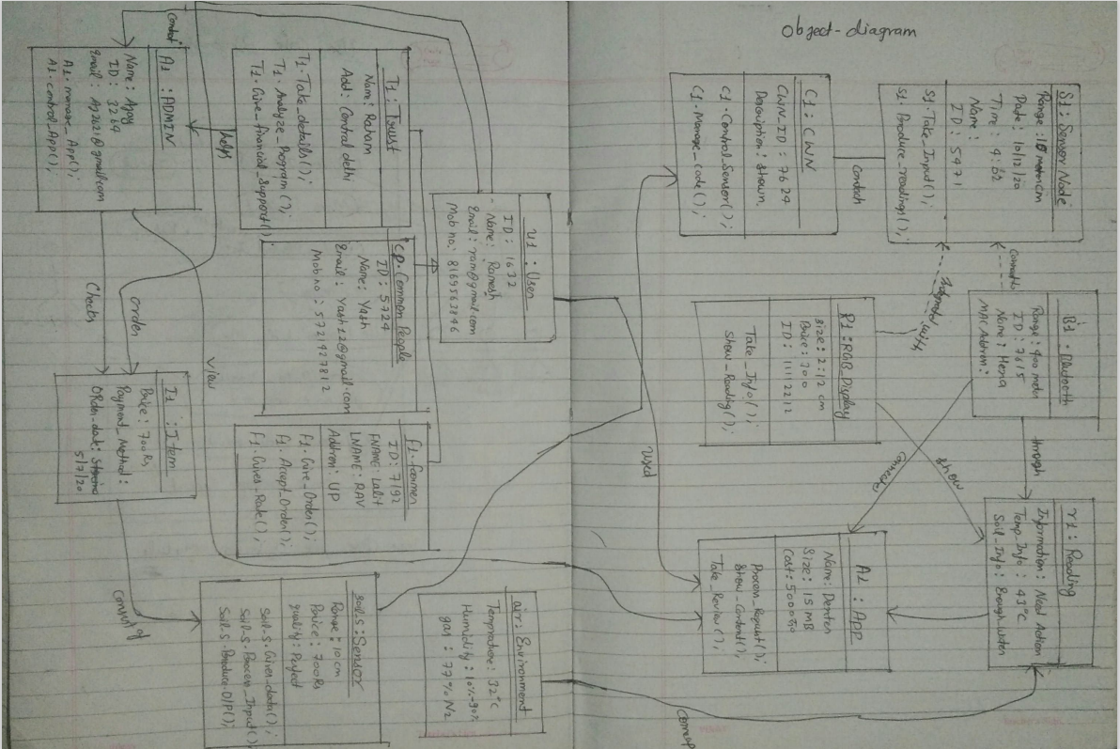

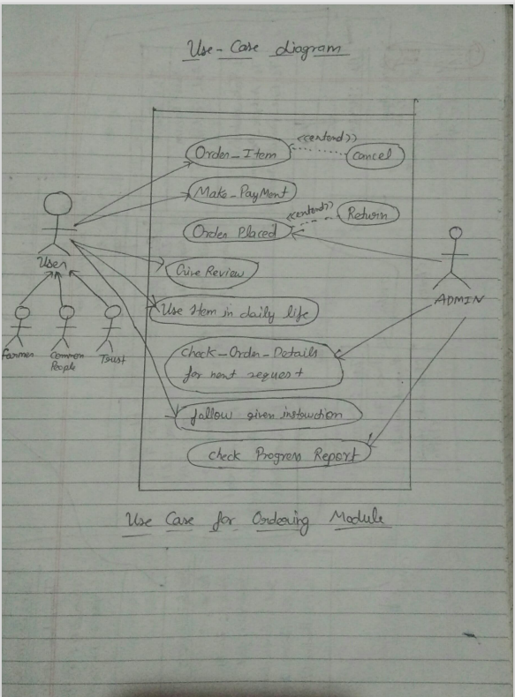

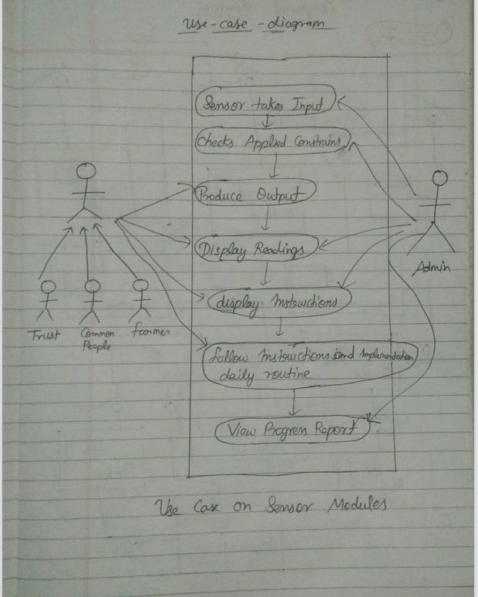

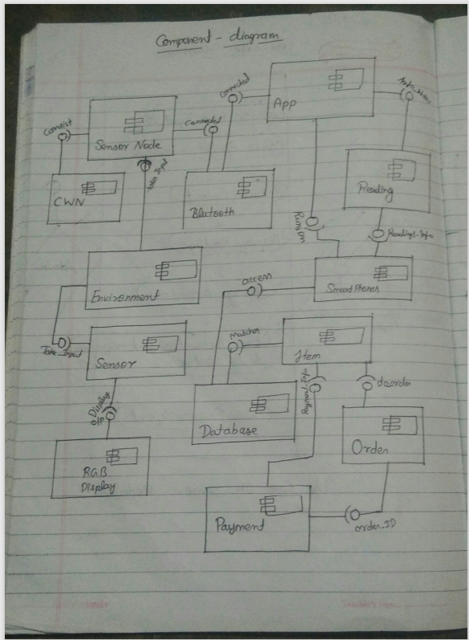

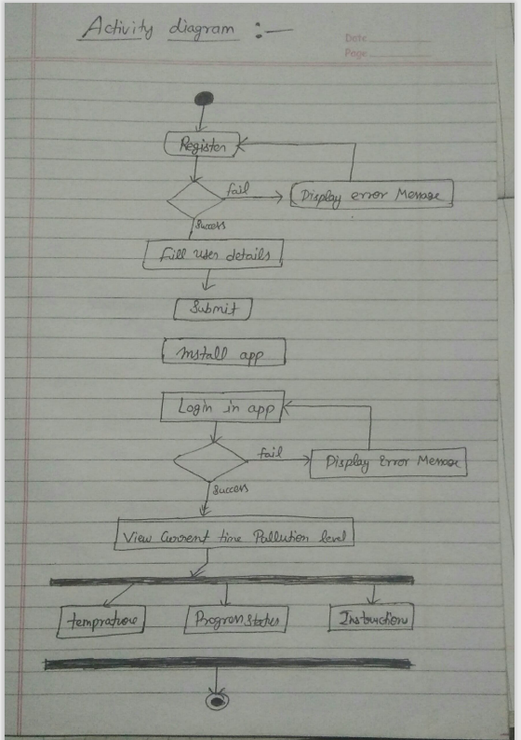

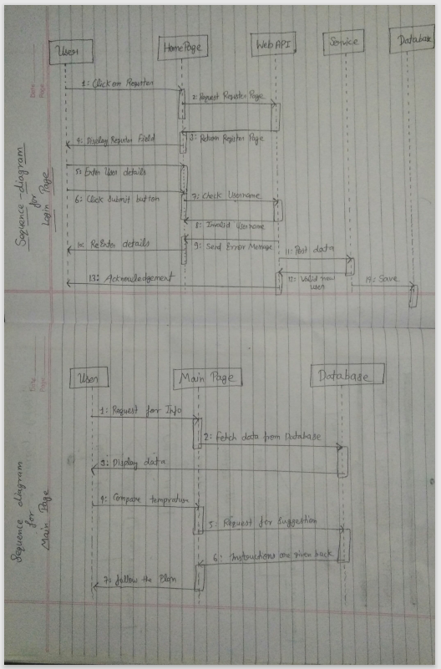

RESULTS AND DISCUSSION

5.1 TEST REPORTS:-

1)FOR SOIL SENSOR:-

| SR. NO. | TEST CASE DESCRIPTION | EXPECTED RESULT | ACTUAL RESULT | REMARK |
| --- | --- | --- | --- | --- |
| 1. | SENSORVALUE GREATER THAN 1000 | NOT IN SOIL | AS EXPECTED | PASS |
| 2. | SENSORVALUE BETWEEN 1000 AND 600 | DRY | AS EXPECTED | PASS |
| 3. | SENSORVALUE BETWEEN 600 AND 370 | HUMID | AS EXPECTED | PASS |
| 4. | SENSORVALUE BELOW 370 | WATER | AS EXPECTED | PASS |

2)FOR DHT11 SENSOR:-

| SR. NO. | TEST CASE DESCRIPTION | EXPECTED RESULT | ACTUAL RESULT | REMARK |
| --- | --- | --- | --- | --- |
| 1. | WHEN NOT CONNECTED TO SOIL SENSOR | DISCONNECTED | AS EXPECTED | PASS |
| 2. | WHEN CONNECTED TO SOIL SENSOR | HUMID | AS EXPECTED | PASS |

3)FOR LOGIN PAGE:-

| SR. NO. | TEST CASE DESCRIPTION | EXPECTED RESULT | ACTUAL RESULT | REMARK |
| --- | --- | --- | --- | --- |
| 1. | USER ENTERS CORRECT CREDENTIALS | LOGIN SUCCESSFUL!!! | AS EXPECTED | PASS |
| 2. | USER ENTERS WRONG CREDENTIALS | LOGIN FAILED!!! | AS EXPECTED | PASS |

4)FOR FEEDBACK:-

| SR. NO. | TEST CASE DESCRIPTION | EXPECTED RESULT | ACTUAL RESULT | REMARK |
| --- | --- | --- | --- | --- |
| 1. | IF FEEDBACK SUBMITTED | SUBMITTED | AS EXPECTED | PASS |
| 2. | IF FEEDBACK NOT SUBMITTED | PLEASE SUBMIT UR RESPONSE | AS EXPECTED | PASS |

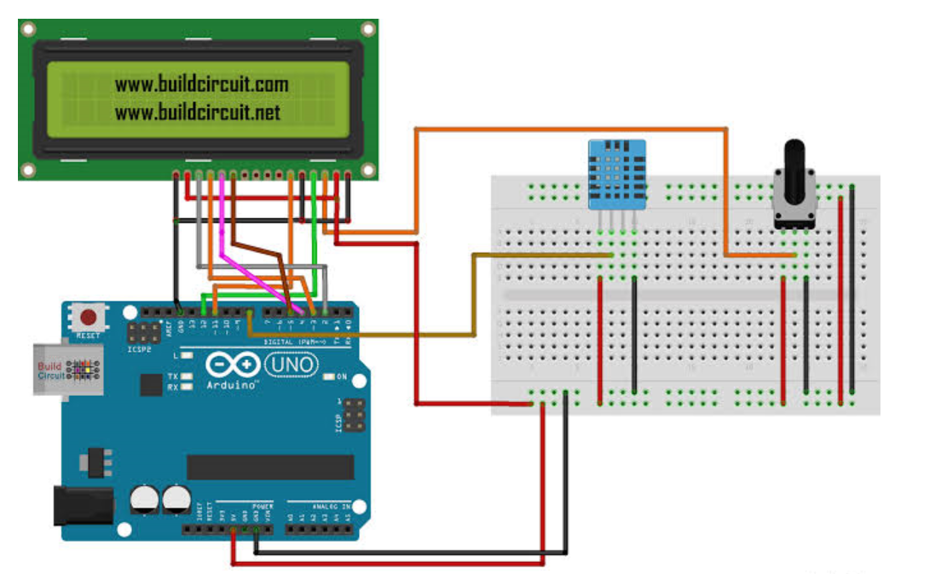

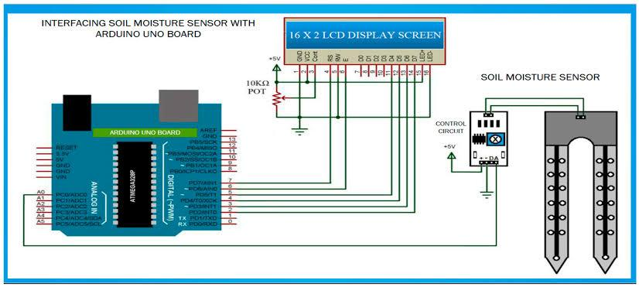

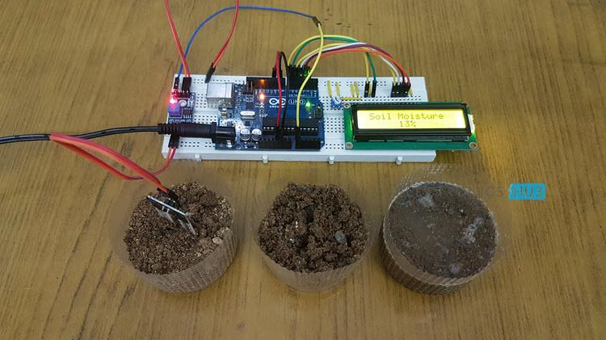

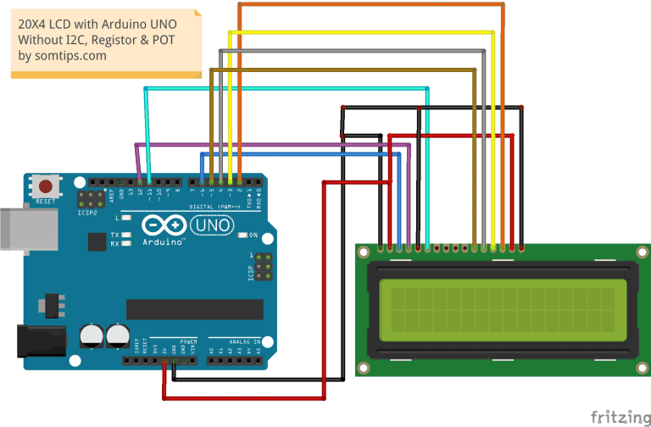

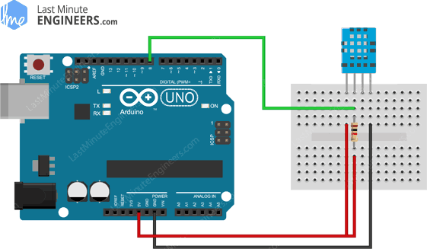

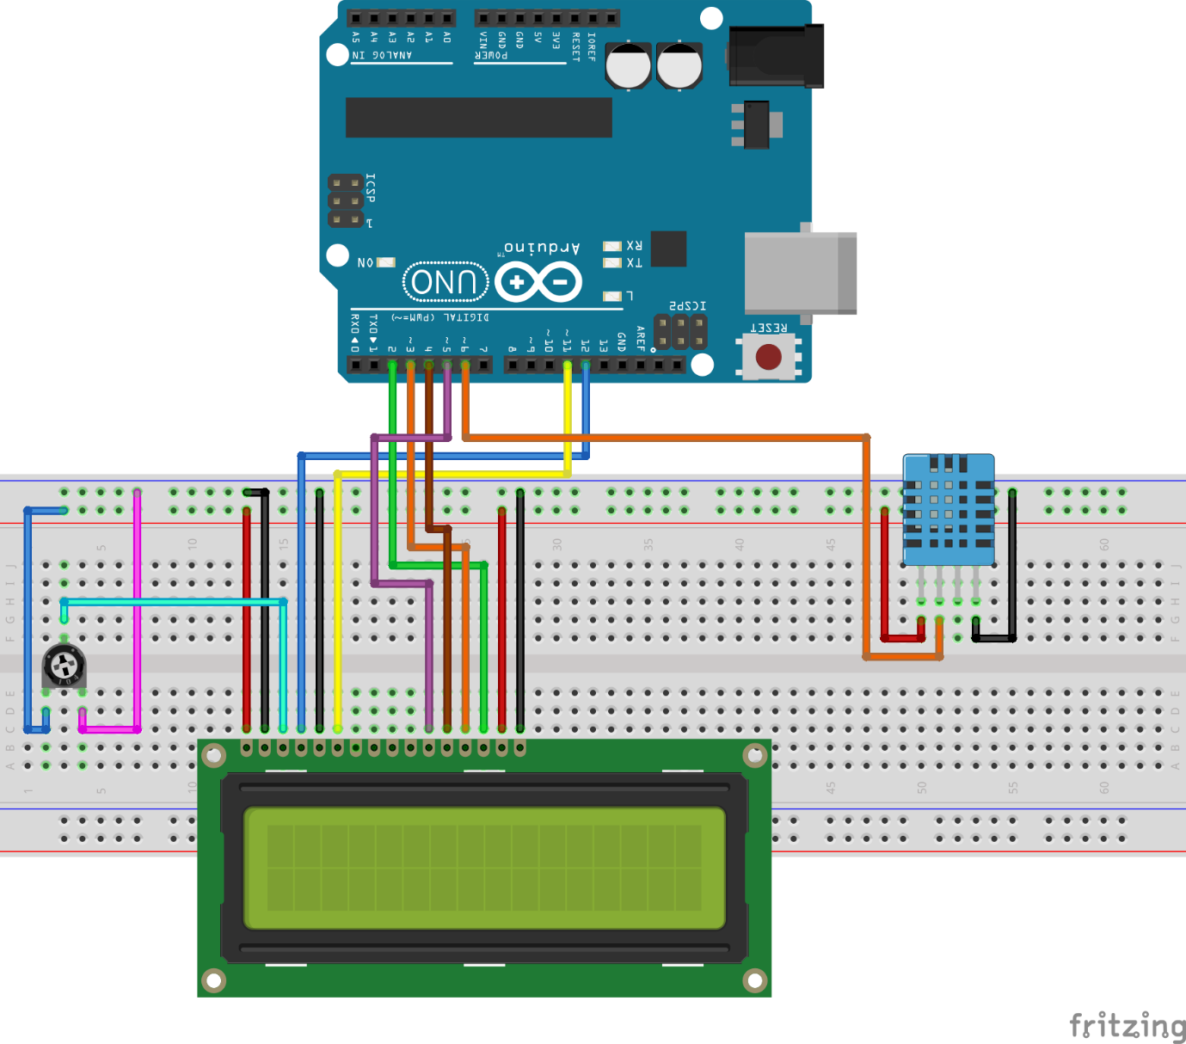

CONCLUSION

6.1 CONCLUSION:-

The aim of the project is to give knowledge about the temperature and the amount of water and other things required for plants so that they can sustain in the environment and we could get good source of food and farmers could get a good source of earnings. It basically integrates soil sensor and dht11 so that they could get to know about the level of water present in soil and is it reliable for their crop or not. If the sensor is not in soil it shows disconnected or not in soil message same if its dry soil it will show dry if the soil is humid in nature it will show that and if the amount of water is more in soil it will show water message on the screen.

Maybe it can be a great idea of developing it for new upcoming farmer generation so they so try and see if the crops are getting enough amount of water or not to make them sustainable and live longer it could also save their crops from dying and could also save their lifes.

6.2 LIMITATIONS:-

1. IT NEEDS POWER SUPPLY TO WORK WITH.

2. SOIL SENSOR PROBE GETS EASILY CORRODED IF STAYED LONG IN WATER.

3. DHT11 SENSOR GETS EASILY HEATED UP AND CAN SHOW WRONG READINGS

SOMETIMES.

4.EVEN THE LCD DISPLAY GETS ITS BACKLIGHT EASILY UNAVAILABLE FOR USE.

6.3 FUTURE SCOPE:-

1. HELPS TO SUSTAIN CROPS.
2. MAKES A PERSON KNOWLEDGEABLE.
3. TELLS US THE AMOUNT OF WATER IN SOIL SO WE COULD MANAGE A PARTICULAT CROP.

GLOSSARY

GND:GROUND

VCC:VOLTAGE AT COMMON COLLECTOR

A0:ANALOG OUTPUT PIN 0

A1:ANALOG OUTPUT PIN 1

USB:UNIVERSAL SERIAL BUS

USB 2.0:UNIVERSAL SERIAL BUS 2.0

VSS: Voltage Source Supply

VDD: positive power supply

VEE: The negative supply was called VEE where “E” stands for emitter.

RS: Register Select

RW: Read/Write

E:ENABLE

D0:DIGITAL OUTPUT PIN 0

D1: DIGITAL OUTPUT PIN 1

D2: DIGITAL OUTPUT PIN 2

D3: DIGITAL OUTPUT PIN 3

D4: DIGITAL OUTPUT PIN 4

D5: DIGITAL OUTPUT PIN 5

D6: DIGITAL OUTPUT PIN 6

D7: DIGITAL OUTPUT PIN 7

LED: Light Emitting Diode